SQL Questions for CIE

1) For the following relation schema:

employee(employee-name, street, city)

works(employee-name, company-name, salary)

company(company-name, city)

manages(employee-name, manager-name)

Queries

1. Find the names, street address, and cities of residence for all employees who work for 'First Bank Corporation' and earn more than $10,000.

2. Find the names of all employees in the database who live in the same cities as the companies for which they work.

3. Find the names of all employees in the database who live in the same cities and on the same streets as do their managers.

4. Find the names of all employees in the database who do not work for 'First Bank Corporation‘

5. Find the names of all employees in the database who earn more than every employee of 'Small Bank Corporation'. Assume that all people work for at most one company.

Solutions

1. select employee.employee-name, employee.street, employee.city from employee, works where employee.employee-name=works.employee-name and company-name = 'First Bank Corporation' and salary > 10000)

2. select e.employee-name from employee e, works w, company c where e.employee-name = w.employee-name and e.city = c.city and w.company-name = c.company-name

3. select p.employee-name from employee p, employee r, manages m where p.employee-name = m.employee-name and m.manager-name = r.employee-name and p.street = r.street and p.city = r.city

4. select employee-name from works where company-name <> 'First Bank Corporation‘

5. select employee-name from works where salary > all (select salary from works where company-name = 'Small Bank Corporation')

2) CUSTOMER (cust #: int , cname: string, city: string)

ORDER (order #: int, odate: date, cust #: int, ord-Amt: int)

ORDER – ITEM (order #: int, Item #: int, qty: int)

ITEM (item # : int, unit price: int)

SHIPMENT (order #: int, warehouse#: int, ship-date: date)

WAREHOUSE (warehouse #: int, city: string)

1. List the no. of order placed by customer no. 5

2. List item nos and and its quantity of order no. 5

3. List the average order amount where "for the current year“

4. List the no. of orders placed by each customer

5. List the customer names who have not ordered for item no. 10.

6. List customer details who has the largest order amount

7. List the names of customers who have ordered at least 10 items

Solutions

1. SELECT COUNT(CO.ORDERNO) FROM CORDER CO WHERE CO.CUSTNO = 5;

2. SELECT ITEMNO,QTY FROM ORDERITEM WHERE ORDERNO = 5;

3. SELECT AVG(ORDAMT) FROM CORDER WHERE ODATE LIKE '%13';

4. SELECT COUNT(*) FROM CORDER GROUP BY CUSTNO;

5. SELECT C.ENAME FROM CUSTOMER C,CORDER CO

WHERE C.CUSTNO = CO.CUSTNO AND CO.ORDERNO != 10;

6. SELECT C.ENAME,C.CUSTNO,C.CITY FROM CUSTOMER C,CORDER CO

WHERE C.CUSTNO = CO.CUSTNO AND CO.ORDAMT =

(SELECT MAX(CO.ORDAMT) FROM CORDER CO);

7. SELECT C.ENAME,COUNT(*) FROM CUSTOMER C,CORDER CO

WHERE C.CUSTNO = CO.CUSTNO GROUP BY C.ENAME HAVING COUNT(*) >= 10;

3) Consider the following relation schema

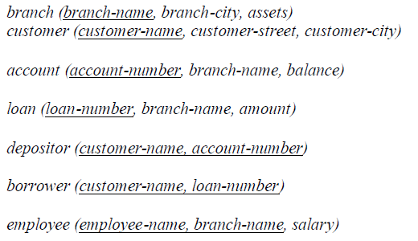

1. Find all account whose balance is smaller than 500.

2. Find all name of customers whose city is in Brooklyn

3. Find all employees whose salary is greater than 1400 and working branch is not ‘Downtown’

4. Calculate the average salary of all employees and show the average salary as “avg_salary”

5. Calculate the number of customer for each account

6. Show all account_number, branch_name and corresponding branch_city

Solutions

1. Find all account whose balance is smaller than 500.

**Answer**: *select account_name from account where balance < 500;*

2. Find all name of customers whose city is in Brooklyn

**Answer**: *select customer_name from customer where customer_city='Brooklyn';*

3. Find all employees whose salary is greater than 1400 and working branch is not ‘Downtown’

**Answer**: *select * from employee where salary>1400 and branch_name<>’Downtown’;*

4. Calculate the average salary of all employees and show the average salary as “avg_salary”

**Answer**: *select avg(salary) as avg_salary from employee* ;

5. Calculate the number of customer for each account

**Answer**: *select account_number, count(distinct customer_name) from depositor group by account_number;*

6. Show all account_number, branch_name and corresponding branch_city

**Answer**: *select account_number, branch.branch_name, branch_city from account, branch where account.branch_name=branch.branch_name;*